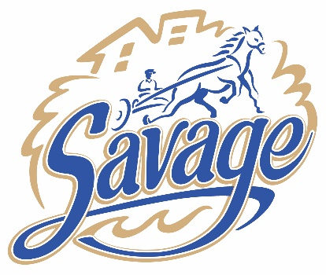 | City of Savage  COMMUNITY EQUITY COMMISSION AGENDA  City Hall Council Chambers  Thursday, May, 15, 2025  6:00 p.m. – 7:00 p.m.
Item
- Call to Order/Roll Call/Pledge of Allegiance
- Additions/Deletions/Modifications to Agenda and Adoption of the Agenda
- Approval of the Minutes
  - April 17, 2025
- Business
  - Discussion on 2026 Budget Requests Priorities
  - Discussion on Juneteenth Celebration for Savage
  - Discussion on Dan Patch Days Participation
  - Discussion on New Resident Welcome Letter and Window Decal.

- Informational Updates
  - Treats and Tunes, Canterbury Park on May 20th, 6-8pm
  - Savage Police Open House, May 31st, 11:00 AM - 1:00 PM, Police Department
  - Rotary Peace Pole Project, 6:15, June 17 at the River Bend Park

- Adjournment
  - Next CEC meeting, Thursday, 6/12/2025 at 6:00 p.m.
DISTRIBUTION
ELECTRONIC:
Full Packet – Laserfiche link: CEC Commissioners, Assistant City Administrator, Christine Kelly, Anthony Miller, Brad Larson, Emily Gunderson, Seng Thongvanh, Regina Dean, Jeremie Bresnahan, Brady Juell, Greg Boatman, Robbie Bunnell, Miranda Harrison, Island Media

Agenda – Email PDF: Ginny Cullen, Lori Folie, Lisa Crist, and Christopher Collins

PAPER:
Agenda: Bulletin Board Post (1)

Full Packet: Public Copy at Meeting

