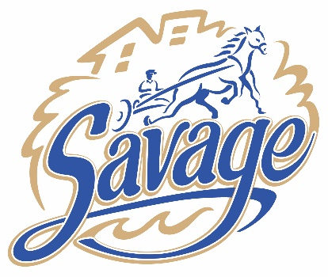 | City of Savage  COMMUNITY EQUITY COMMISSION AGENDA  City Hall Council Chambers  Thursday, January 16, 2025  6:00 p.m. – 7:00 p.m.
Item
- Call to Order/Roll Call/Pledge of Allegiance
- Additions/Deletions/Modifications to Agenda and Adoption of the Agenda
- Approval of the Minutes
  - December 12, 2024
- Business
  - Update on Partnership with the Savage Rotary for installation of Peace Pole in Savage.
  - Update on Community Mural Project
  - Selection of the 2025 Dr. Martin Luther King Jr. Essay/Poetry Contest Winners.

- Informational Updates
  - Mural Community Input Workshop, Saturday, February 22 from 10 a.m. – noon at the Savage Library
  - First Time Home Buyer Workshop, Scott County CDA, February 1st, 2025 – English, 8am – 4:30PM (Doors open at 7:40am) – Savage, MN Library
- Adjournment
  - Next CEC meeting, Thursday, 2/13/2025 at 6:00 p.m.

DISTRIBUTION
ELECTRONIC:
Full Packet – Laserfiche link: CEC Commissioners, Assistant City Administrator, Janet Williams, Anthony Miller, Brad Larson, Emily Gunderson, Seng Thongvanh, Regina Dean, Jeremie Bresnahan, Rodney Seurer, Greg Boatman, Robbie Bunnell, Miranda Harrison, Island Media, Savage Pacer amalm@swpubs.com, gaamot@swpub.com

Agenda – Email PDF: Ginny Cullen, Lori Folie, Lisa Crist, and Christopher Collins

PAPER:
Agenda: Bulletin Board Post (1)

Full Packet: Public Copy at Meeting

