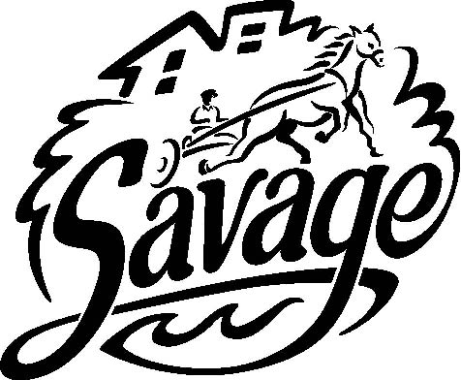 | City of Savage  PARKS, RECREATION AND NATURAL RESOURCES COMMISSION AGENDA  City Council Chambers  February 26, 2024, 7:00 p.m.
Agenda
WELCOME to this meeting of the Savage Parks, Recreation and Natural Resources Commission (PRNRC).
The meeting will be conducted in the City Council Chambers.

The audio and video of the PRNRC meeting will be streamed live on the City website, enabling
viewers at home to listen to the meeting.
- Call to Order/Roll Call/Pledge of Allegiance
- Approve Agenda
- Oath of Office
- Nomination and Election of Chair and Vice-Chair
- Minutes
  - Approve Minutes from November 27, 2023
- Business
  - Update on the replacement of the artificial turf at the Savage Sports Center.
  - Receive an update on the Nature Play Area at Hidden Valley Park.
  - Discuss values and attributes for the Police Chief recruitment and appoint a member to the community interview panel on March 7, 2024.
  - PW/Pr Director Update- Verbal
- Adjournment – Next Meeting: Monday, March 25, 2024
DISTRIBUTION
ELECTRONIC:
Full Packet – Email PDF: Commissioners (9); Brad Larson, Greg Boatman, Trent Jutting, Andy Weldon,
Chris Dill, Jay Lair, Robbie Bunnell, Tammy Coyne, Jo Schmitt, Emily Gunderson (10);
Savage Pacer (2); Island Media (2)
Agenda – Email MS Word: Ginny Cullen, Chris Collins, Lisa Crist, Anthony Miller, Lori Folie (5)

PAPER COPY:
Full Packet: Extra Copy, Public Copy, PW Copy (3)
Agenda Only: Public Copy – City Hall Bulletin Board (1)

