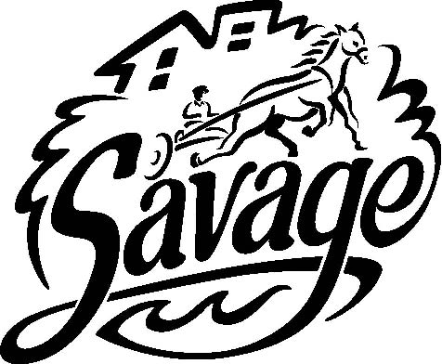 | City of Savage  PARKS, RECREATION AND NATURAL RESOURCES COMMISSION AGENDA  City Council Chambers  December 27, 2022, 7:00 p.m.
Agenda
WELCOME to this meeting of the Savage Parks, Recreation and Natural Resources Commission (PRNRC).
The meeting will be conducted in the City Council Chambers.

The audio and video of the PRNRC meeting will be streamed live on the City website, enabling
viewers at home to listen to the meeting.
- Call to Order/Roll Call/Pledge of Allegiance
- Approve Agenda
- Minutes
- Approve Minutes
- Old Business
- None
- New Business
  - Review and provide feedback in regard to proposed modifications to Trost Tower site and request for additional use of park land - Terri Dill, Senior Planner
  - Hidden Valley Park Pollinator Enhancements - Jesse Carlson, Water Resources Manager
- PW Director Update – verbal
- Adjournment – Next Meeting: Monday, January 23, 2023
DISTRIBUTION
ELECTRONIC:
Full Packet – Email PDF: Commissioners (9); Brad Larson, Greg Boatman, Trent Jutting, Andy Weldon,
Chris Dill, Jay Lair, Robbie Bunnell, Tammy Coyne, Jo Schmitt, Emily Gunderson (10);
Savage Pacer (2); Island Media (2)
Agenda – Email MS Word: Ginny Cullen, Chris Collins, Lisa Crist, Anthony Miller, Lori Folie (5)

PAPER COPY:
Full Packet – United States Mail: None
Full Packet: None
Agenda Only: Public Copy – City Hall Bulletin Board (1)

